12 . Design DFA using a simulator to accept the input string “a” ,”ac”,and ”bac”.

AIM: To design DFA using a simulator to accept the input string “a” ,”ac”,and ”bac”.

TRANSITION DIAGRAM:

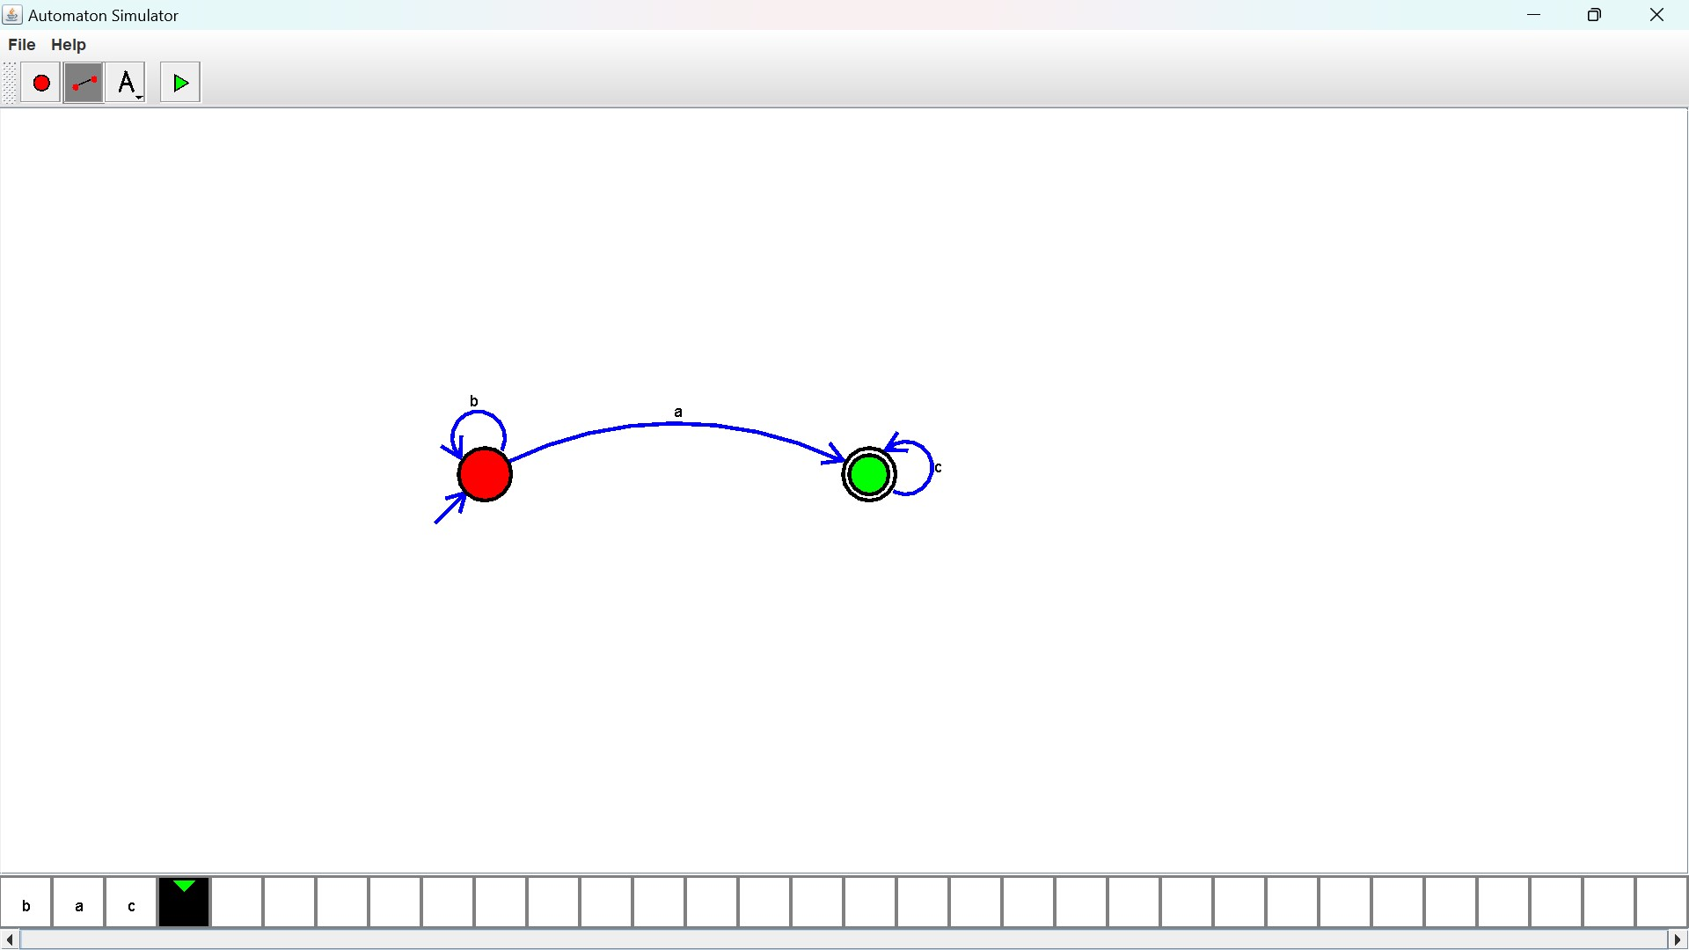

**RESULT**: All the given strings are satisfied.